Do It Anyway
July 7, 2016
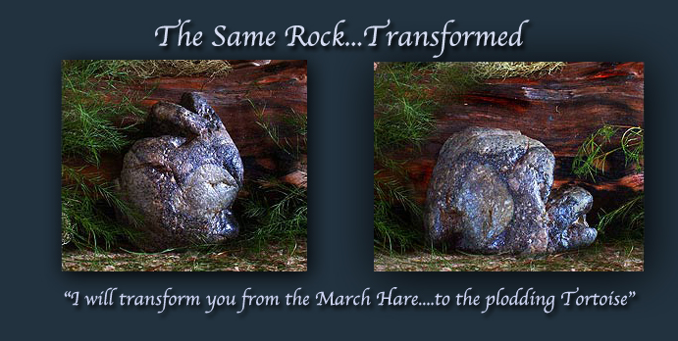
The guidance and love of Jesus is with us, dear Heartdwellers.

This is a short message, because it needs to stick and help us be motivated with the things you are most intimidated by. For me, it’s that painting the Lord has given me to do and also my voice, which needs to be built up. Whether we have a day, a week, or a month - or even more, I want to give Him my all and that means every moment I am alive and here.

Those things that you run from because they demand more effort are still gifts from the Lord. They are talents we don’t want to bury…do we? I mean, I cringe at the very thought that I would have nothing to give to the Lord for His investment in me. He has invested me with gifts that need cultivation. As the Scriptures say, 'Sing with all your skill to the Lord.' He has invested time, resources and healing into my life so I could do these things, and most of all He has given me you who pray and make sacrifices for this ministry and I don’t want to let you down.

Each of us has comparable gifts and even those who love and pray for us are a gift. We want to give a return on His investment, but we do have an enemy who is very clever and knows our weak spots. I’d venture to say that every one of us has a lazy bone somewhere. Reasoning, ”Aw, that’s too much work! We’re going to be raptured soon, there’s no time for that!” Well, even if that’s true, still we have given Him our ALL every day of our life. And some of those things will yield fruit before we’re raptured, so there are no excuses to put off using our gifts.

That said, yesterday was a sad comedy of errors from start to finish! It started with a medical emergency that, thank the Lord, got worked out. And ended with several hours of work on the painting that has to be totally redone today. But actually, it was something that had to be tried, so I didn't really waste my time doing it. But I have noticed that there are bad days before the good days. And that if we persevere and are faithful and don’t give up... the good days will mount up and get the job done.

Every song I have ever written went with tortoise speed. Not like Ezekiel, who sits down and the words, melody and execution come out in one night. No, for me it’s hours of studied, painstaking work until a song is written, chords are mapped out, fingers compliant…lots of practice.

When the Lord first gave me the gift of music, He put a vision in the sky: clouds that looked like a turtle. Having been born in March, I’ve always been chided about being a March Hare - so I could relate to the story of the tortoise and the hare and the race the tortoise won by his day after day plodding. That was the furthest thing from my mind. I loved being the quick and nimble hare. But when Jesus gave me the gift of music, He told me I must be like the tortoise.

Then after seeing the movie Nemo, He gave me an upgrade: I could be the sea turtle that flowed in the Holy Spirit current. I had this vision appear to me in the sky, too, as a confirmation. But it still hasn’t been easy. Just to seal the word, He gave me a rock that looks like a tortoise when it’s turned one way and like a bunny when it’s turned the other - that’s the illustration I used for this message.

So, that’s the background on this message.

The Lord began, “My Beloved, don’t ever run from Me when things get confused and you find yourself tripping over everything. The more the enemy stirs up trouble, the more you need to sit and settle with Me. I know that last night you were in a place where you needed to paint, and that’s why we did that. But as a general rule, the message will come first."

Lord, is that You who is encouraging me to set aside a little time for the piano everyday?

"It wouldn’t hurt would it? That is one of your gifts and I do wish to see you cultivate it, little by little by little. You and I would both feel better if you would do this. Also, it will be an encouragement to your husband to do the same. Both of you are way too cowed by the phantoms of this and the phantoms of that. It is your gift. Press on through! Really, ‘the violent take Heaven by force!’ This is what is needed, because your adversaries are strong. You must be stronger. Besides, this will be a consolation to all of us.

"Clare, be busy about My business and cultivate what I have given you, Dear One. Yes, you can fit it in. Yes, you can. These roadblocks are demonic, not in the real universe and the only way around them is through; pushing through and not listening to all the objections and buts that are thrown at you."

Oh, Jesus, you said where I am weak, You are strong. And it has been said that a soul will be the strongest at the point of which they were the weakest. I desperately need your help. Please, help me to be obedient. I really feel like a foolish woman, so easily led astray it is laughable. In fact, I’m sure I’m a byword to the demons.

The Lord continued, "Even if that were true, what do you care what they think? They’re a pack of liars and you have Me to overcome your faults with. So let’s forge ahead…what do you say?"

With Your help, I can do all things?

"Exactly."

What can I change to cooperate with You more and get through this?

"Listen for Me very carefully and do it anyway. In other words, when you don’t feel like doing it, do it anyway. Usually fear is at the root of that feeling, but it’s buried under so many pretexts. Like, 'You don’t have the time. You should be doing this, not that. You’re not getting anywhere with this. (That’s THE biggest lie) What’s the use? The rapture is around the corner.'

"All of these are tools the enemy uses to dissuade you. But if you do it anyway, you will foil his attempts to stop you. Your biggest enemy right now is distractions. Useless things that will get you nowhere, and you will look back and say, 'Why did I waste my time on that?' All those who are successful have one thing in common: they didn’t waste time on ‘can’t because.’ Rather, they plowed into their work ignoring the smoke screens. They made conscious decisions to choose their gift rather than silly, empty things.

"It’s like a ladder, Clare. One step up leads to another step up and eventually to the top. One step down leads to another step down and eventually the bottom.

"Success builds upon success; discipline builds upon discipline. Slothfulness drags you down further and further until you feel hopelessly discouraged. Sloth is indeed a force to be reckoned with. It comes in many different guises, but behind its reasoning is a lie. You CAN do this. I DO want you to use your gift. If you make it a point to be using your gifts one at a time in between necessary duties and charity; if you make it a point to be engaging one of your gifts several times throughout the day - you are on the road to success and freedom from the fears that create roadblocks in your thinking and cause you to give up too easily.

"Sickness is a deterrent. But it is also a gift to be used for intercession. But do not allow the enemy to confuse sickness with sloth. That can be a slippery logic to easily throw you off course. Once you have recovered yourself, go at it with deliberate intention to succeed and not allow anything to take you away from it.

"There is a cost to greatness. There is much sacrifice that must take place before a gift has become ‘great’ and useful to Me. And when you have several such gifts, it can be confusing as to which one to use. Go back to your last instruction from Me, if you don’t know what to do next. What was the last thing I told you? Remember? I told you to work on the painting and music, in between the messages. I also told you that you had time for both. I have sent you helpers. I have made a way for you. Don’t waste time, My Love, don’t waste it; it is a precious commodity and a gift I have given you. Please, don’t waste it.

"Yes, these are lessons everyone can learn from, because this issue is universal and the greatest thief of My gifts to souls. The greatest thief. Therefore be on your guard against this, and don’t permit it to block you any longer. Fight your way through it.

"DO IT ANYWAY!!!"

